Check out the biology mentoring program that pairs faculty for mutual support.

Where to take students to share your work**

American Society for Cell Biology, Dec 15-19, 2012, San Francisco
Ecological Society of America, August 5-10, 2012, Portland, OR
American Society for Microbiology, June 22-25, 2012, San Francisco
American Society for Plant Biology, July 20-24, 2012, Austin, TX
Genetics Society of America, four different groups—see web site
Benthic Ecology Meeting, 2013 meeting TBA
Society for the Study of Reproduction, August 12–15, 2012, State College, PA
American Association of Cancer Research—look for 2013
World Stem Cell Summit, Oct. 3-5, West Palm Beach, FL
State Academies of Science
**See related article, pg3

Division Newsletter, Spring, 2012
Volume 3, Issue 1

Feature Article: Revitalizing Genetics Courses through Collaborative Research

CUR Biology
Most science educators agree that the best way for students to learn science is to have them do science. Unfortunately, implementing a pedagogical model based on this ideal is easier said than done. Through the generous financial support of an Associated Colleges of the South Andrew W. Mellon Faculty Renewal Grant, CUR Councilors Mary Miller (Rhodes College) and Pamela Hanson (Birmingham-Southern College (BSC)) overcame the challenges of integrating teaching and research, which dramatically revitalized their Genetics courses. Specifically, Hanson and Miller had their students use the budding yeast Saccharomyces cerevisiae as a model organism for characterizing the mechanism of action of indazolium trans-[tetrachlorobis(1H-indazole) ruthenate (III)], an anticancer ruthenium complex more commonly known as KP1019.
Although early clinical trials of KP1019 are promising, the mechanism by which cancer cells internalize and are killed by KP1019 is a subject of active investigation. In Fall 2010, 62 BSC genetics students contributed to this on-going line of research by assessing the drug’s ability to inhibit growth, increase mutation rate, and induce expression of a reporter gene that serves as a marker of genotoxicity. Students then applied these techniques to yeast strains either lacking or overexpressing genes thought to be modulators of KP1019 sensitivity. To complement this approach, 16 Rhodes genetics students examined the impact of KP1019 on the cell cycle. During Spring 2011 these students also used microarrays to determine which genes are induced or repressed in response to drug treatment. Through the use of a wiki to share data, the work of the BSC students impacted both the experimental design and the interpretation of data collected at Rhodes. Furthermore, the data collected by Rhodes students will be built upon by BSC students in the 2011-2012 academic year.
By engaging our students in a bona fide research project that is collaborative in nature, students experienced the excitement of discovery and reported many gains comparable to those reported by undergraduates who engaged in intensive, summer-long research programs funded by the Howard Hughes Medical Institute. Specifically, students at both Rhodes and BSC reported substantial gains in their ability to analyze data, to interpret results, and to understand science and the research process. Furthermore, Rhodes students reported remarkably high gains on skills in science writing. In addition to self-reporting their learning gains, students also indicated that their course-associated research experience was extremely positive. For example, 74% of respondents at BSC reported that the laboratory experience met or exceeded their expectations, and 70% reported that they were mildly or very satisfied with the experience. Besides improvements in student attitudes, Miller and Hanson noted substantial improvements in their own morale. The same genetics laboratories had been taught at both schools for several years, thus the new laboratory activities generated excitement, enthusiasm, and a genuine sense of renewal. In addition to the positive pedagogical outcomes, the data collected by students at BSC and Rhodes were highly reproducible. Several aspects of the work established by BSC students, including the implication of DNA repair and stress response pathways in KP1019’s mechanism of action, were recapitulated in the Rhodes studies. It is important to note that the students did not simply repeat each other’s experiments, but rather took distinct approaches to address the was quite high, and Hanson and Miller anticipate with great excitement following these preliminary findings to their logical conclusions in future iterations of this project.
Through this inter-institutional collaboration, students were exposed to the nature of collaborative studies in the “real world”, which energized and deepened their experience. More importantly, they engaged in relevant research on a promising anti-cancer drug. This allowed important discussions not only of “how” research is done, but “why” it is done. Students were able to gauge not only the technical expertise necessary to carry out the research projects, but they also had the opportunity to recognize the potential impact of their work.

http://WWW.CUR.ORG

Editor's E-Mail:
templelm@jmu.edu

Greetings from Arlington, Virginia, my temporary home for the next two years as I serve as a Program Director at the National Science Foundation. Being only a stone’s throw away from CUR’s National Office (NO) in Washington D.C. has enabled me to become more involved with their activities. Last month I attended CUR Dialogues and mid month I plan to attend Posters on the Hill. Both events are wonderful occasions to celebrate the importance of undergraduate research, and I encourage you to attend these activities if you ever have the opportunity. Further, last November the US House of Representatives passed a resolution designating National Undergraduate Research Week April 11-15. To help celebrate I ask you to plan some event on your campus and contact your local and state representatives to recognize undergraduate research week.
The Biology Division, recognized last year by the NO as “Best Division” currently has 711 members that are represented by 25 elected Councilors. Within our Division, the Advocacy Committee created tools to use when advocating for undergraduate research; the Mentoring Committee established several mentoring relationships; the Program Review Unit coordinated five Biology Department reviews/two interdisciplinary reviews; the Mentor Awards Committee recognized three outstanding undergraduate mentors; and the Student Travel Awards Committee funded eight students. My appreciation goes out to the Biology Councilors for their outstanding work and dedication to CUR. I encourage each of you to become engaged in Divisional activities and to serve as a voice to recruit new members into CUR. If you have suggestions for ways to improve the Biology Division and/or activities you would like to see us engage in, please let me know. Enjoy your spring. Vicki Martin

Division News and Information

News from members

Doing research with undergraduates (and others) in India. Your editor traveled with American Society for Microbiology Funds to a state university just north of Delhi, India, to teach a 2 week original research course, modeled on the Phage Hunting program of HHMI’s Science Education Alliance and Univ. of Pittsburgh. Undergraduates simply do not do research in India, so my six UGs, as they call themselves, felt privileged (see photo below. In fact, for some MS students, this was their first authentic lab research project. Cultural differences are certainly there: I had to get used to being called Ma’am and treated with great respect, as well as breaking often for tea, but the excitement generated by this experience for them was identical to what you see amongst young scientists here and anywhere else, I presume.

There is considerable interest from the US government and individual agencies in developing more scientific collaborations internationally. Other CUR members are involved in active partnerships. If this is an avenue you wish to pursue but don’t know where to start, please contact me.

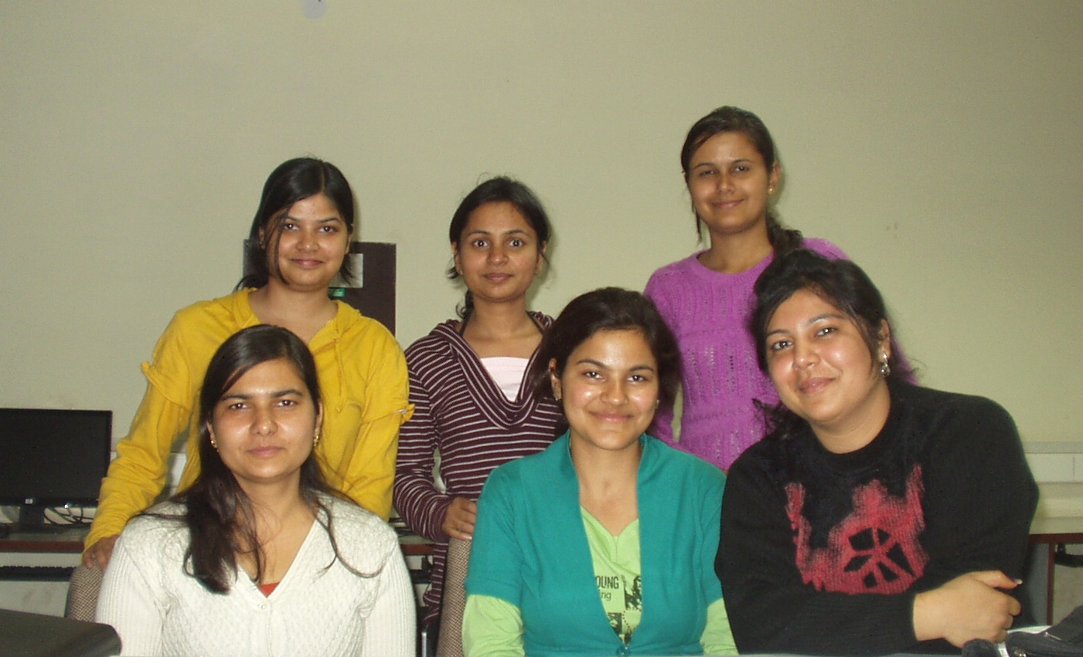
CUR Biology Mentor Awardees:
CUR offers something for everyone:
- Posters on the Hill
- Mentoring
- Institutes/workshops, for example
  - Proposal Writing
  - Starting research programs at PUIs
- CUR Dialogues
- Advocacy
Biology division travel awards were presented to these students:
About Our Organization… www.cur.org

What’s all this about meetings? The first time I took undergraduates to a national meeting, they were awestruck by two things: (1) at the exhibits they saw kits by Qiagen and wondered that we had the same things in our lab—we must be doing “real” science, and (2) authors of papers they had read visited them at their posters and asked them questions as though they were real scientists. If you’ve never experienced this, get moving! This can be life changing for your students. On page 1 is sampling of meetings that the CUR biology councilors attend. Consider national, regional, and local meetings; each of these has advantages and disadvantages. Also consider education meetings where student contributions are solicited. Funding a problem? Yes, it is for nearly everyone. This is a great target for internal funds, alumni sources, and local industry/business. There is nothing more appealing to givers than funding that goes directly to students. Match your local funds with CUR biology travel grants.

